db.book.insertMany(

[

{"book_title":"mean web development",

"author":"Amos Q. Haviv",

"publication":" Packt Publishing Ltd",

"edition":"1.0.0",

"year_of_publication":"September 2014",

"ISBN_No":978-1-78398-328-6,

"type_of_book":"textbook",

} ,

{

"book_title":"Big Data Anaylatics",

"author":"Seema Acharya",

"publication":" Packt Publishing Ltd",

"edition":"2.0.0",

"year_of_publication":"September 2019",

"ISBN_No":928-2-78398-234-7,

"type_of_book":"textbook",

},

{

"book_title":"Machine Learning",

"author":"Tom Mitchell",

"publication":" O'Reilly Media",

"edition":"3.0.0",

"year_of_publication":"28 july 2016",

"ISBN_No":908-3-76543-123-8,

"type_of_book":"textbook",

},

{

"book_title":"Java",

"author":"Ketty Sierra",

"publication":" Packt Publishing Ltd",

"edition":"5.0.0",

"year_of_publication":"September 2014",

"ISBN_No":978-1-78398-328-9,

"type_of_book":"textbook",

},

{

"book_title":"C#",

"author":"Andrew Troelsen",

"publication":" WP publishers",

"edition":"4.0.0",

"year_of_publication":"2001",

"ISBN_No":342-1-87623-128-10,

"type_of_book":"textbook",

}

]);

Retrive the books which contains title as java

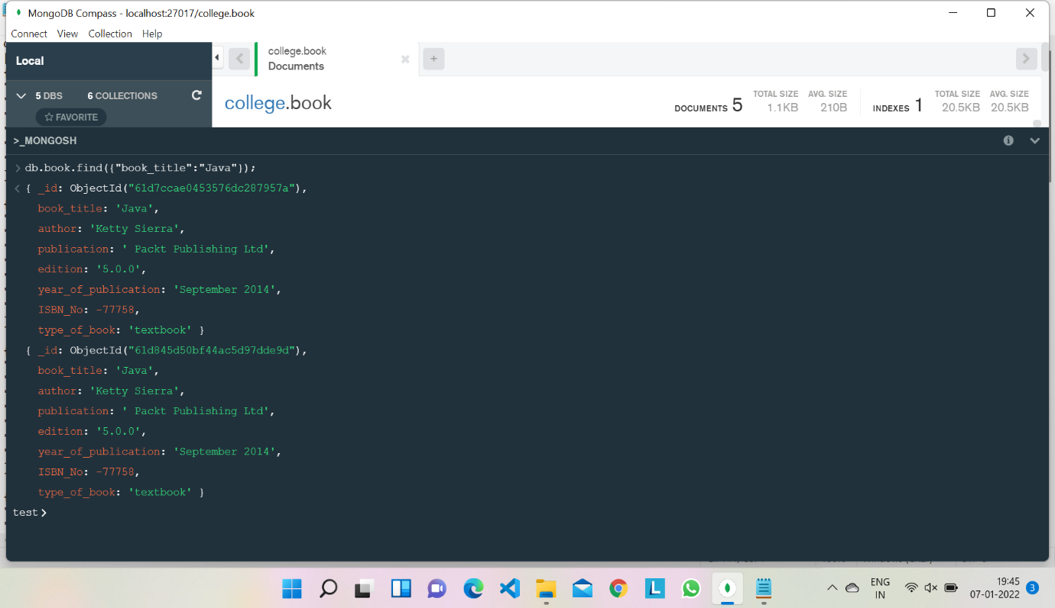

Retrive the name of author who has publish more than 2 books

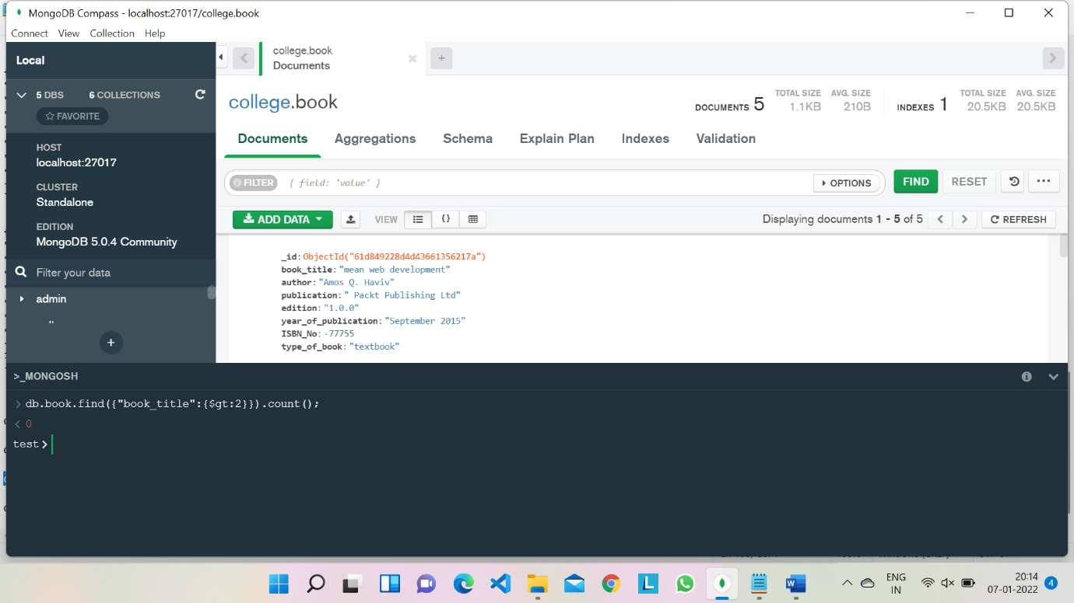

Retrive the books who’s edition is between 3to 4

